08 — ACID Properties & Isolation
2520030034
P. Pratik Kumar
- COMMIT — Deposit
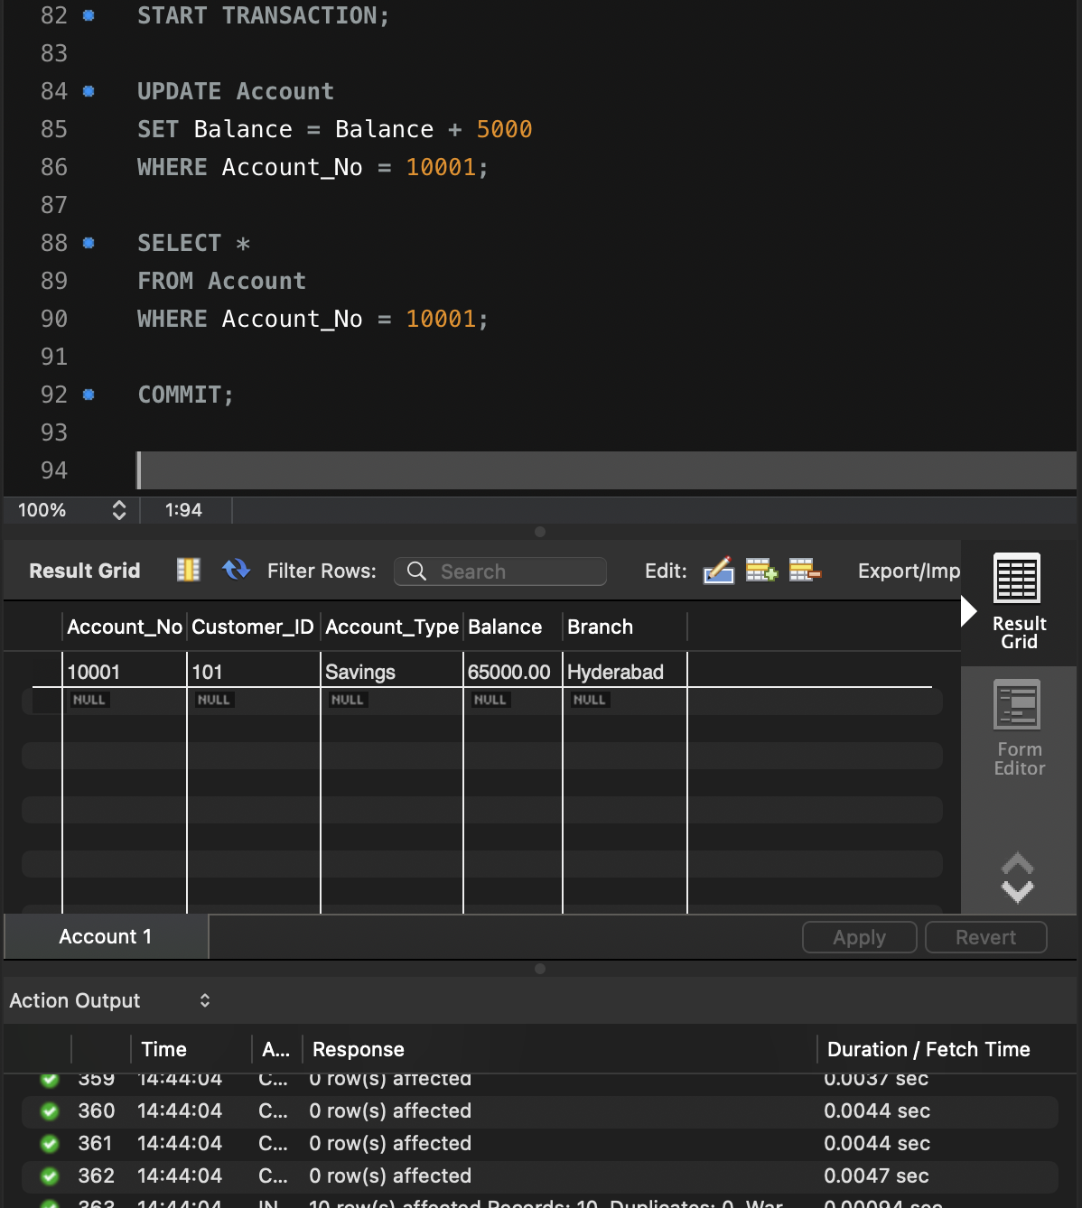
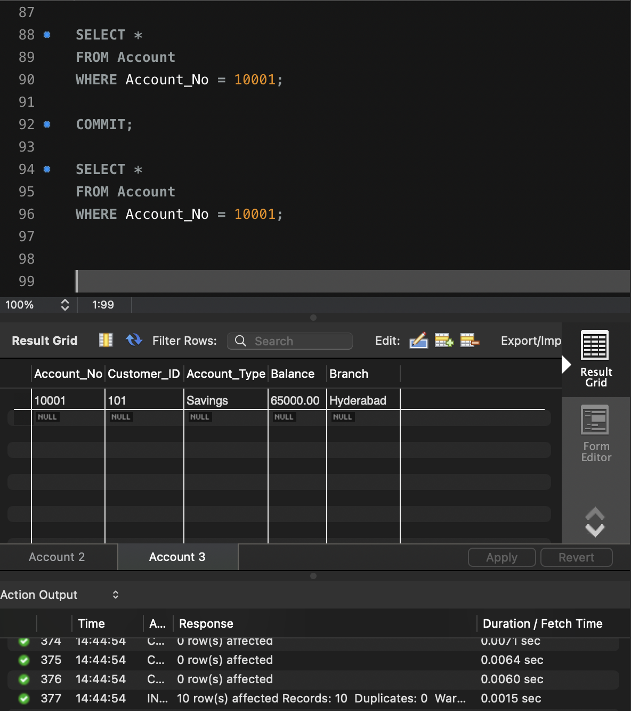
- ROLLBACK — Cancel Withdrawal
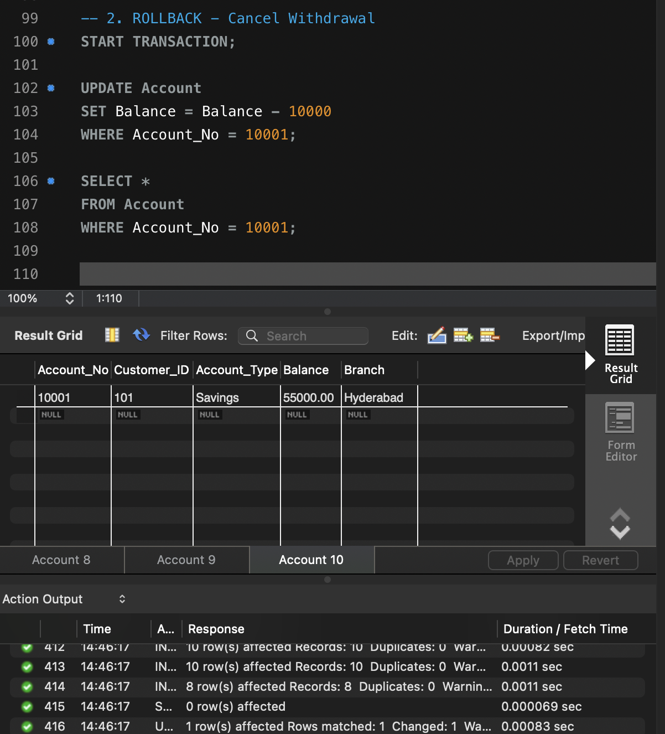
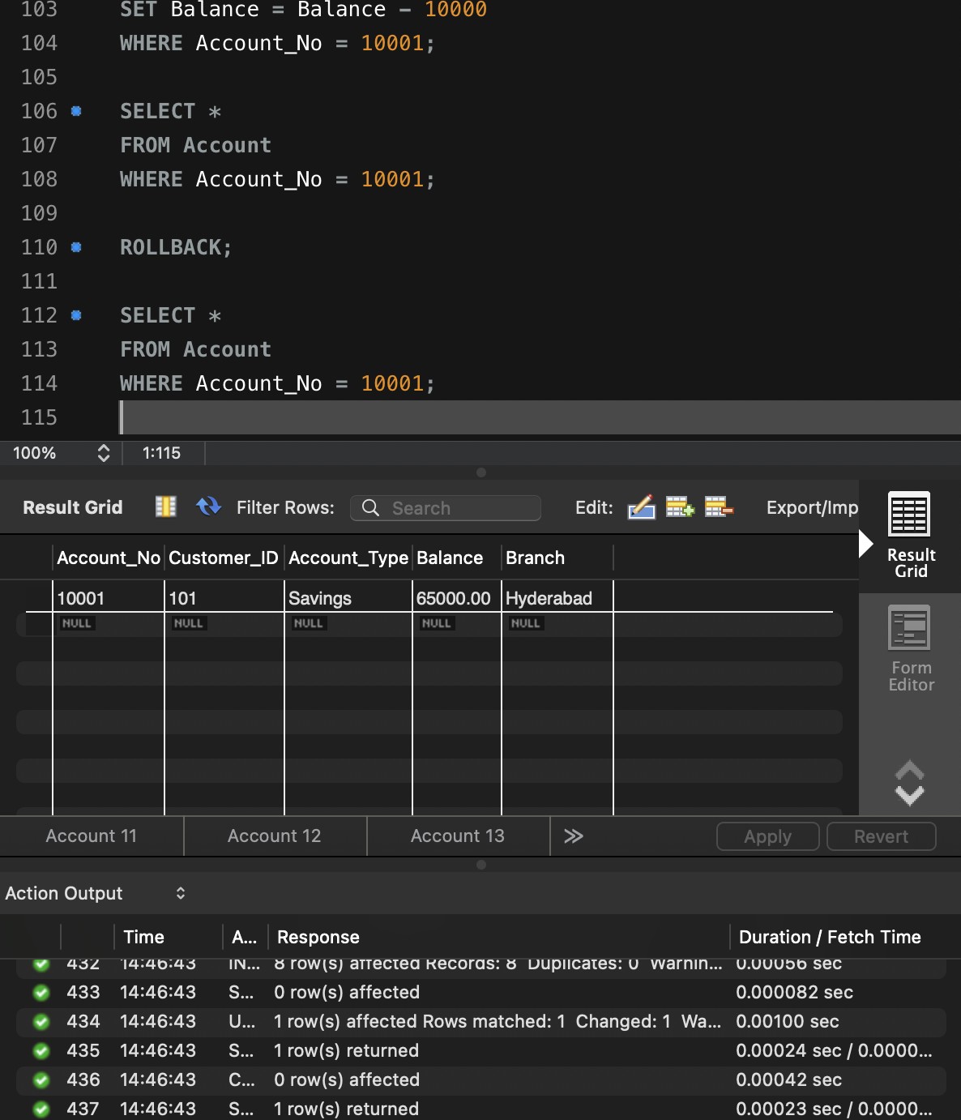

- SAVEPOINT — Partial Rollback
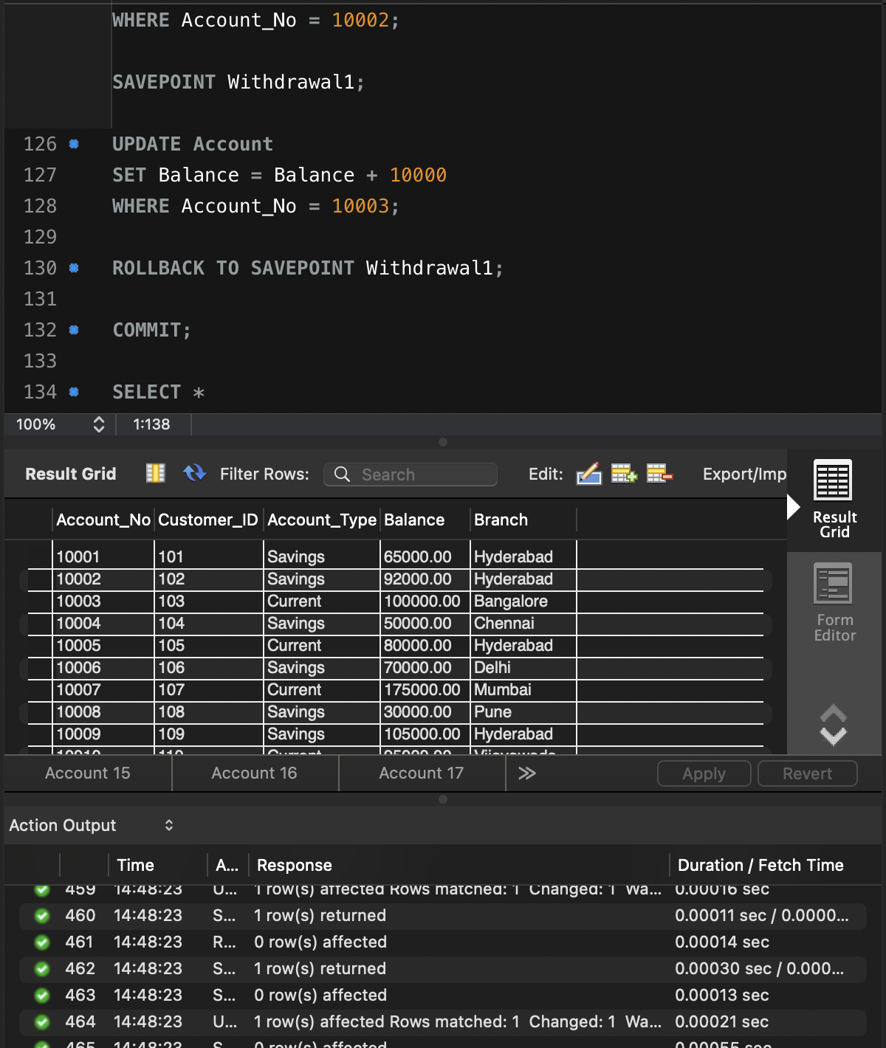
- BANK TRANSFER — COMMIT
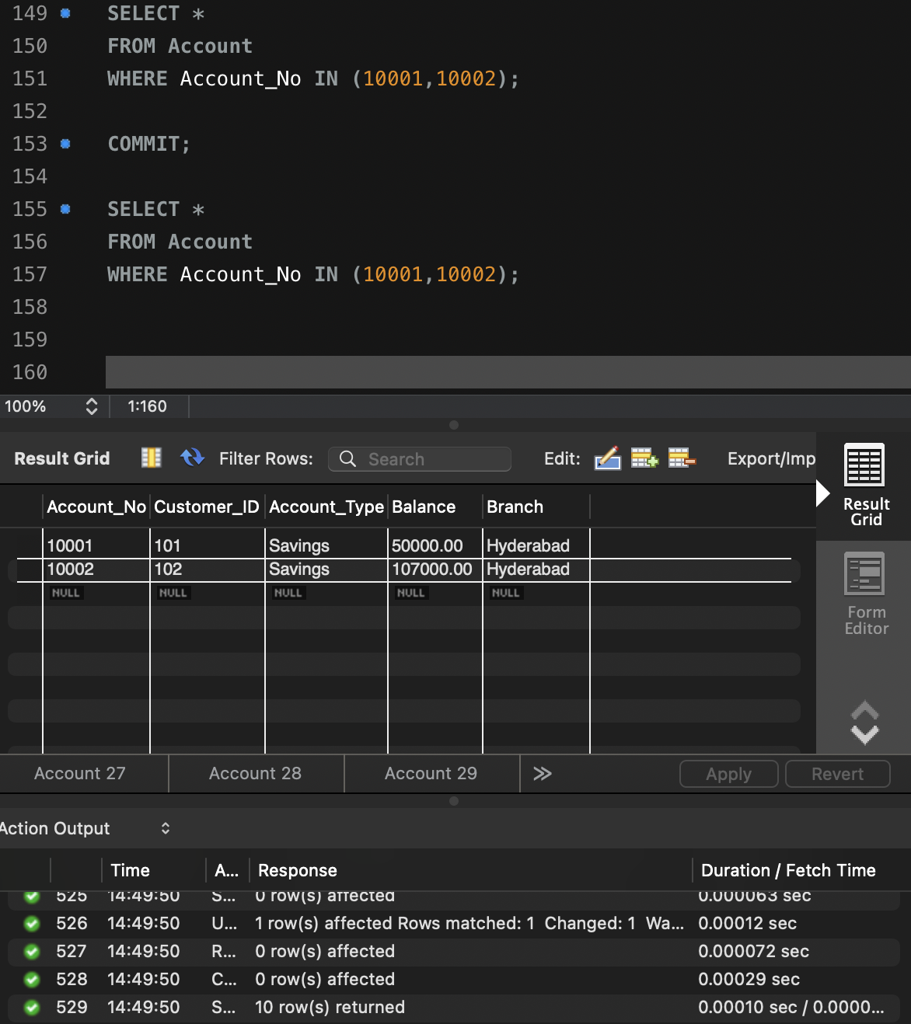

- CHECK CURRENT ISOLATION LEVEL
